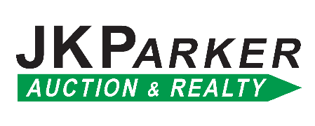

[*www.jkparkerauction.com*](http://www.jkparkerauction.com)

|  |
| --- |
| **Broker Participation/Buyer Registration** |
| Broker/Realtor Name: _ |
| Real Estate Agency: |
| Address: |
| Email : _ |
| Prospective Buyer's Name(s): ___ |
| Address: |

Phone: ( )

The above Broker/Realtor hereby wishes to register the above Client as a prospective Buyer for the Auction being conducted by JK Parker Auction & Realty Services on **March 29, 2025**.

The property being sold is located at 38409 Lake Rd, Shawnee, OK 74801

**JK Parker Auction & Realty Services** hereby agrees to pay to the registering Broker/Realtor on the following terms and conditions, a Commission of _____% of the winning Bid, due at closing, if the above Client is the successful High Bidder at the auction and closes on the terms of the Conditions of Sale and Purchaser's Agreement. Broker/Realtor understands that to qualify for this commission, this registration form must be received by JK Parker Auction Services **no later** than no later than 48 hours prior to the Auction, and the Broker/Realtor must attend the Auction with the Client.

**TERMS OF THE AUCTION:** Real Estate is being sold on an **AS-IS** basis in accordance to the Terms and Conditions of Sales Agreement provided by the sellers on the day of the auction. Announcements made on the date and time of the Auction take precedence over all printed materials.

There will be no exceptions to these terms and conditions and **no oral registrations** will be accepted.

Client will need to register to bid using their driver license to obtain a bidder number the day of the auction.

The signatures below indicate acceptance of the above terms and conditions. Form must be **completed in full** or it will not be accepted. **JK Parker Auction & Realty Services** must receive registrations no later than 48 hours prior to the start of the Auction at 10:00 AM, **March 29, 2025**.

|  |  |  |
| --- | --- | --- |
| Prospective Purchaser: |  | Date: |
| Print Name: |  |  |
| Broker/Realtor: |  | Date: |
| Print Name: |  |  |

|  |
| --- |
| **Mail or email to:** 744 Yoachum, Harrah, OK 73045 • [info@jkparkerauction.com](mailto:info@jkparkerauction.com) |
| ph: Office (405) 454-2628 or Cell (405) 630-9184 |